

###### IRB INFORMED CONSENT or AGREEMENT TO PARTICIPATE FORM

IRB No.:15-104-WIL-XPD Rev. No./Date:

**Consent** **Form Title:** For student participants

**Project Title**: Simulating Real-World Legal Decisions

**Principal Investigator**: Miko M. Wilford

**Contact Information:** Email: [Miko_Wilford@uml.edu](mailto:Miko_Wilford@uml.edu) or Phone: (978) 934-3975

**Co-PI(s)**: Misha Rabinovich (Misha_Rabinovich@uml.edu)

**Student Investigator(s)**: Maria Camila Borrero, Courtney Carnevale, Melanie Case, Annmarie Khairalla, Jordanne Love, and Thomas Nelson

**Date Submitted**: 08/04/2016

*This form has been approved for use by the UML IRB and is valid for up to one year from the approval date. (PIs -Give a copy of this form to the study participant after they sign it. Originals are to be retained by the PI.*)

**Authorized IRB Approval Signature**:       **Approval Date**:

**1. Study Purpose**: The purpose of this research is to increase our scientific understanding of plea-bargaining and the factors that impact plea outcomes.

**2. Procedure and Duration**: If you agree to participate in this study, you will be walked through 1-3 simulated legal scenarios, which are designed to mimic real world environments. Prior to the simulations you might be asked to create an avatar or one will be created for you—this avatar will represent you in the virtual environment. Each simulation will involve the following phases: you will be charged with a crime, you will be presented evidence related to the crime, you will be faced with potential sentences if found guilty of the crime, you will be judged legally innocent or guilty of committing the crime. After each simulation you will be asked a number of questions designed to assess your perceptions of the simulation. All simulations should take approximately 15-30 minutes to complete.

**3. Eligibility:** You must be 18 years of age or older to be eligible for participation in this study.

**4. Potential Risks and Discomfort**: You have the right to withdraw from the survey at any time without any consequences. It is possible that you will experience mild stress or boredom during the simulations; however, you are welcome to take short breaks in between simulations. Further, the researchers will separate the data you produce from your identity by regularly (each week) removing names and emails and replacing them with unique participant IDs. Any record matching a participant ID to his/her name or email will be erased at the conclusion of the academic semester (after any potential issues with academic research credits have been resolved).

If you find that you become distressed because of your participation, please contact the study’s principal investigator: Professor Miko Wilford (Miko_Wilford@uml.edu or 978-934-3975).

**5. Incentives/Compensation (if any)**: You will receive 1 academic research credit for completion of this study.

**6. Anticipated Benefits to the Subject or to Non-subjects**: There are likely no direct benefits to you, however, as a participant in this study, you may learn a little about plea-bargaining and experience first-hand how some psychological research is conducted. Further, this research will contribute to the little that is known about the plea-bargaining process. This information will provide guidance for further research.

**7. Right to Refusal or Withdrawal of Participation**: You do not have to participate in this study. Your participation in this study is completely voluntary and you may refuse to participate or quit the study at any time without penalty. As noted above, if you require a break, you are welcome to take one between simulations.

**8. Assurances of Privacy and Confidentiality**: The only identifying information we will record is your email address. This is necessary to ensure you receive your research credit. However, as stated above, emails will be kept in a separate file from the data and will be erased entirely at the conclusion of the semester. Further, all data files will be maintained on password-protected computers and servers.

**9. Additional Information (Include contact information for researchers)**: If you have any questions about this study or your participation, please contact the principal investigator at [Miko_Wilford@uml.edu](mailto:Miko_Wilford@uml.edu).

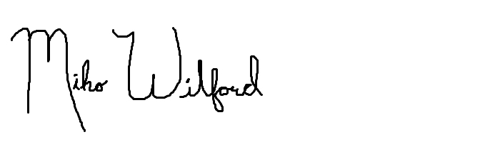**PRINCIPAL INVESTIGATOR SIGNATURE(S)**

1. Printed Name: Miko Wilford Signature: Date: 08/04/16

2. Printed Name: Misha Rabinovich Signature: Macintosh HD:Users:misha:Downloads:signature.jpg Date: 08/04/16

**PARTICIPANT SIGNATURE**

*I understand the potential risks and/or discomforts that have been described in this document and by the researcher. By entering my first name and email below below, I am indicating that I have read this document, had the opportunity to discuss any concerns and ask questions about the research, understand the risks and consequences from participating in this study, and am granting consent to participate in this research.*

**Research Participant:**

First Name (ONLY):       UML Email Address:       Date: